INSERT PARTNER LOGO HERE

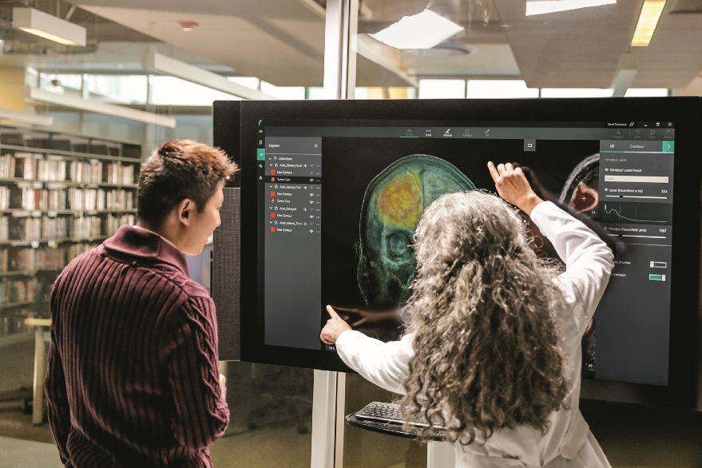
Microsoft devices for Healthcare

Helping you put your patients first

Physicians are fighting constant battles to balance quality face-to-face patient time with their core administrative responsibilities. They require a reliable mobile solution that can help them work efficiently and productively— from wherever they are.
Healthcare professionals can’t afford to be locked down to one single workstation anymore or held back by slow and unpredictable legacy tech. They need devices that allow them to find time for personal consultations, without compromising on the quality of the experience with patients.
That’s why the healthcare industry needs Surface. It’s light, mobile, and powerful. It can go wherever the healthcare professional goes and, crucially for patients, it keeps all their private information secure. All in one device.

Maximize physician efficiency
Juggling face-to-face patient time with administrative responsibilities has always been a struggle. Nurses and practitioners need an innovative way to overcome these obstacles, achieve more, and focus their energy on what really matters: the patients.
- Access up-to-date patient records and prescriptions in real time and use OneNote to make any necessary notes during visits.
- Capture and process electronic signatures directly on screen using DocuSign to speed up clinical pathways.
- Spend less time traveling to and from single workstations to perform heavy admin processes.

The most productive devices for business
<Partner CTA>

Empower home healthcare
Home health workers are constantly on the move and must work productively and efficiently, no matter what environment they’re in. Whether it’s working on the ward or from their patients’ homes, Surface is always up to the challenge.
- Mobile healthcare professionals and patients can use Surface Pro and access specialized Windows 10 apps, allowing them to be more productive on the go with Surface.
- 13.5 hours of battery life support extended hours working on the move.
- Be confident that patient data is secure, and your organization is compliant, thanks to comprehensive Windows 10 security features.

“With Surface, when I walk in a room, I am ready and engaged with that patient. I can have four active charts open at the same time. On average, we can probably see two more patients a day.”
Dr Nick Patel
Medical Director, Palmetto Health

Save time and money
One of the biggest barriers between healthcare professionals and their patients is time. With Surface, you can bring
up patient details securely in real time, access mobile applications and information from anywhere, and save time by working from one single, mobile device.
- Eliminate delays caused by logging into multiple devices throughout the day.
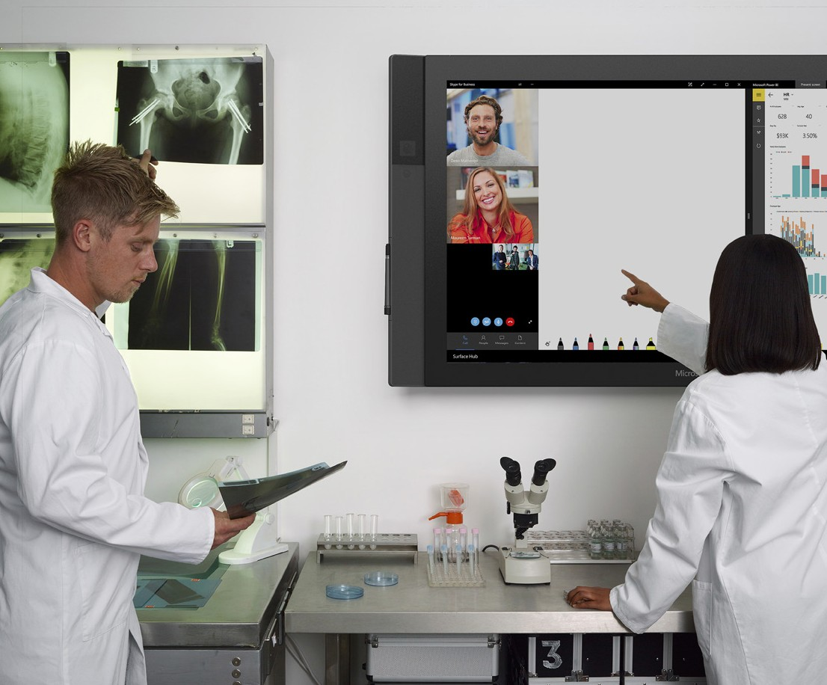
INSERT PARTNER LOGO HERE
Software shown is sold separately.

- Work seamlessly across other Microsoft devices—all supported on Windows 10.
- Efficiency gains using Surface help physicians to see at least two new patients a day on average.

Streamline medical operations
With its HD touchscreen and digital pen, Surface lets you review patient records clearly and make accurate notes and edits in an instant. It doesn’t matter whether you’re accessing important documents on the road, sharing charts with a patient, or presenting to students—Surface has it covered.
- View and share medical images and files clearly using full versions of clinical desktop apps.
- Securely access all patient data anywhere with built-in security features such as BitLocker, TPM, Windows Defender, and Secure Book are keeping protected health information safe.
- Streamline processes and create efficiencies in a hospital or clinic with Windows 10 apps on Surface devices.

INSERT PARTNER DETAILS HERE

The most productive devices for business | <Partner CTA>

